**S1 Java Strings**

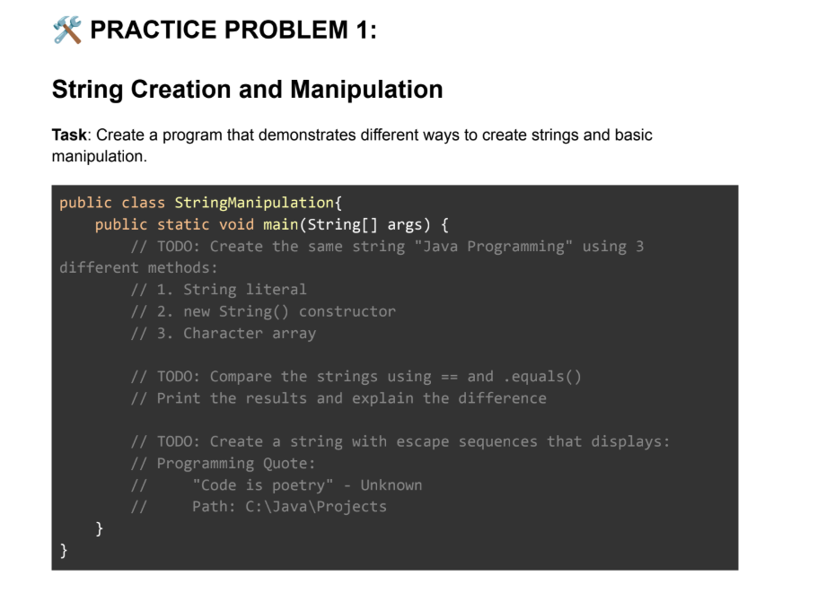

Code:

public class StringManipulation {

public static void main(String[] args) {

String str1 = "Java Programming";

System.out.println(str1);

String str2 = new String("Java Programming");

System.out.println(str2);

char arr[]={'J','a','v','a','P','r','o','g','r','a','m','m','i','n','g'};

String str3 = new String(arr);

System.out.println(str3);

System.out.print("Compare using ==: "+ (str1==str2)+"\n");

System.out.println("Compare using equals: "+(str1.equals(str2)));

}

}

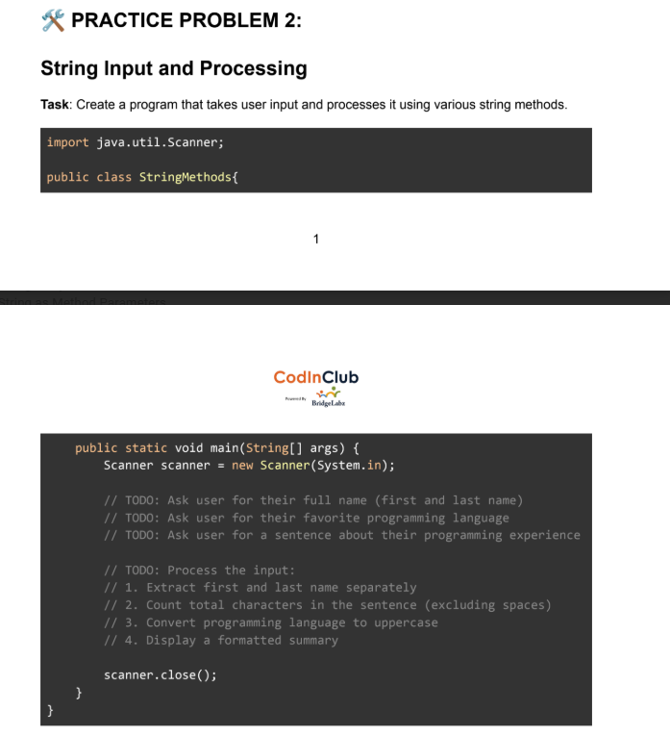

Code:

import java.util.Scanner;

public class StringInput {

public static void main(String[] args) {

Scanner scanner = new Scanner(System.in);

System.out.print("Enter full name: ");

String fullName = scanner.nextLine();

System.out.print("Enter favorite programming language: ");

String language = scanner.nextLine();

System.out.print("Enter a sentence about your programming experience: ");

String sentence = scanner.nextLine();

String firstName = fullName.split(" ")[0];

String lastName = fullName.split(" ")[1];

int charCount = sentence.replace(" ", "").length();

String upperLang = language.toUpperCase();

System.out.println("First Name: " + firstName);

System.out.println("Last Name: " + lastName);

System.out.println("Character count (no spaces): " + charCount);

System.out.println("Language in uppercase: " + upperLang);

scanner.close();

}

}

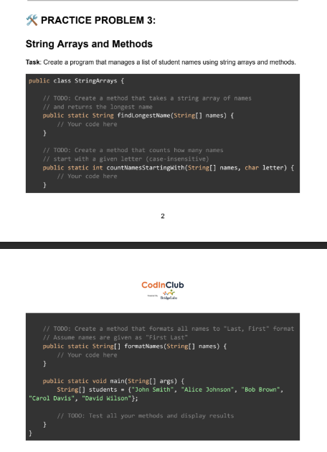

Code:

public class StringArrays {

public static String LongestName(String[] names) {

String longest = names[0];

for (String name : names) {

if (name.length() > longest.length()) {

longest = name;

}

}

return longest;

}

public static int Names(String[] names, char letter) {

int count = 0;

for (String name : names) {

if (name.toLowerCase().charAt(0) == Character.toLowerCase(letter)) {

count++;

}

}

return count;

}

public static String[] formatNames(String[] names) {

String[] formatted = new String[names.length];

for (int i = 0; i < names.length; i++) {

String[] parts = names[i].split(" ");

formatted[i] = parts[1] + ", " + parts[0];

}

return formatted;

}

public static void main(String[] args) {

String[] students = {"John Smith", "Alice Johnson", "Bob Brown", "Carol Davis", "David Wilson"};

System.out.println("Longest Name: " + LongestName(students));

System.out.println("Names starting with 'A': " + Names(students, 'A'));

String[] formatted = formatNames(students);

for (String name : formatted) {

System.out.println(name);

}

}

}

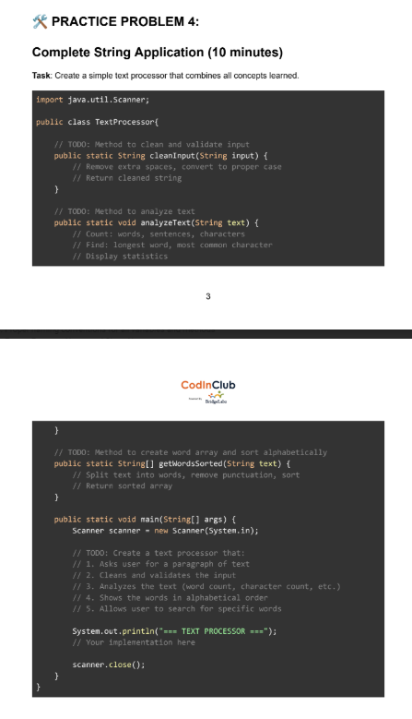

Code:

import java.util.Scanner;

import java.util.Arrays;

public class TextProcessor {

public static void main(String[] args) {

Scanner sc = new Scanner(System.in);

System.out.print("Enter text: ");

String t = sc.nextLine().trim().replaceAll("\\s+", " ");

String[] w = t.split(" ");

String longest = "";

for (String x : w) {

if (x.length() > longest.length()){

longest = x;

}

}

System.out.println("Words: " + w.length);

System.out.println("Characters: " + t.replace(" ", "").length());

System.out.println("Longest word: " + longest);

Arrays.sort(w);

System.out.println("Sorted: " + Arrays.toString(w));

sc.close();

}

}